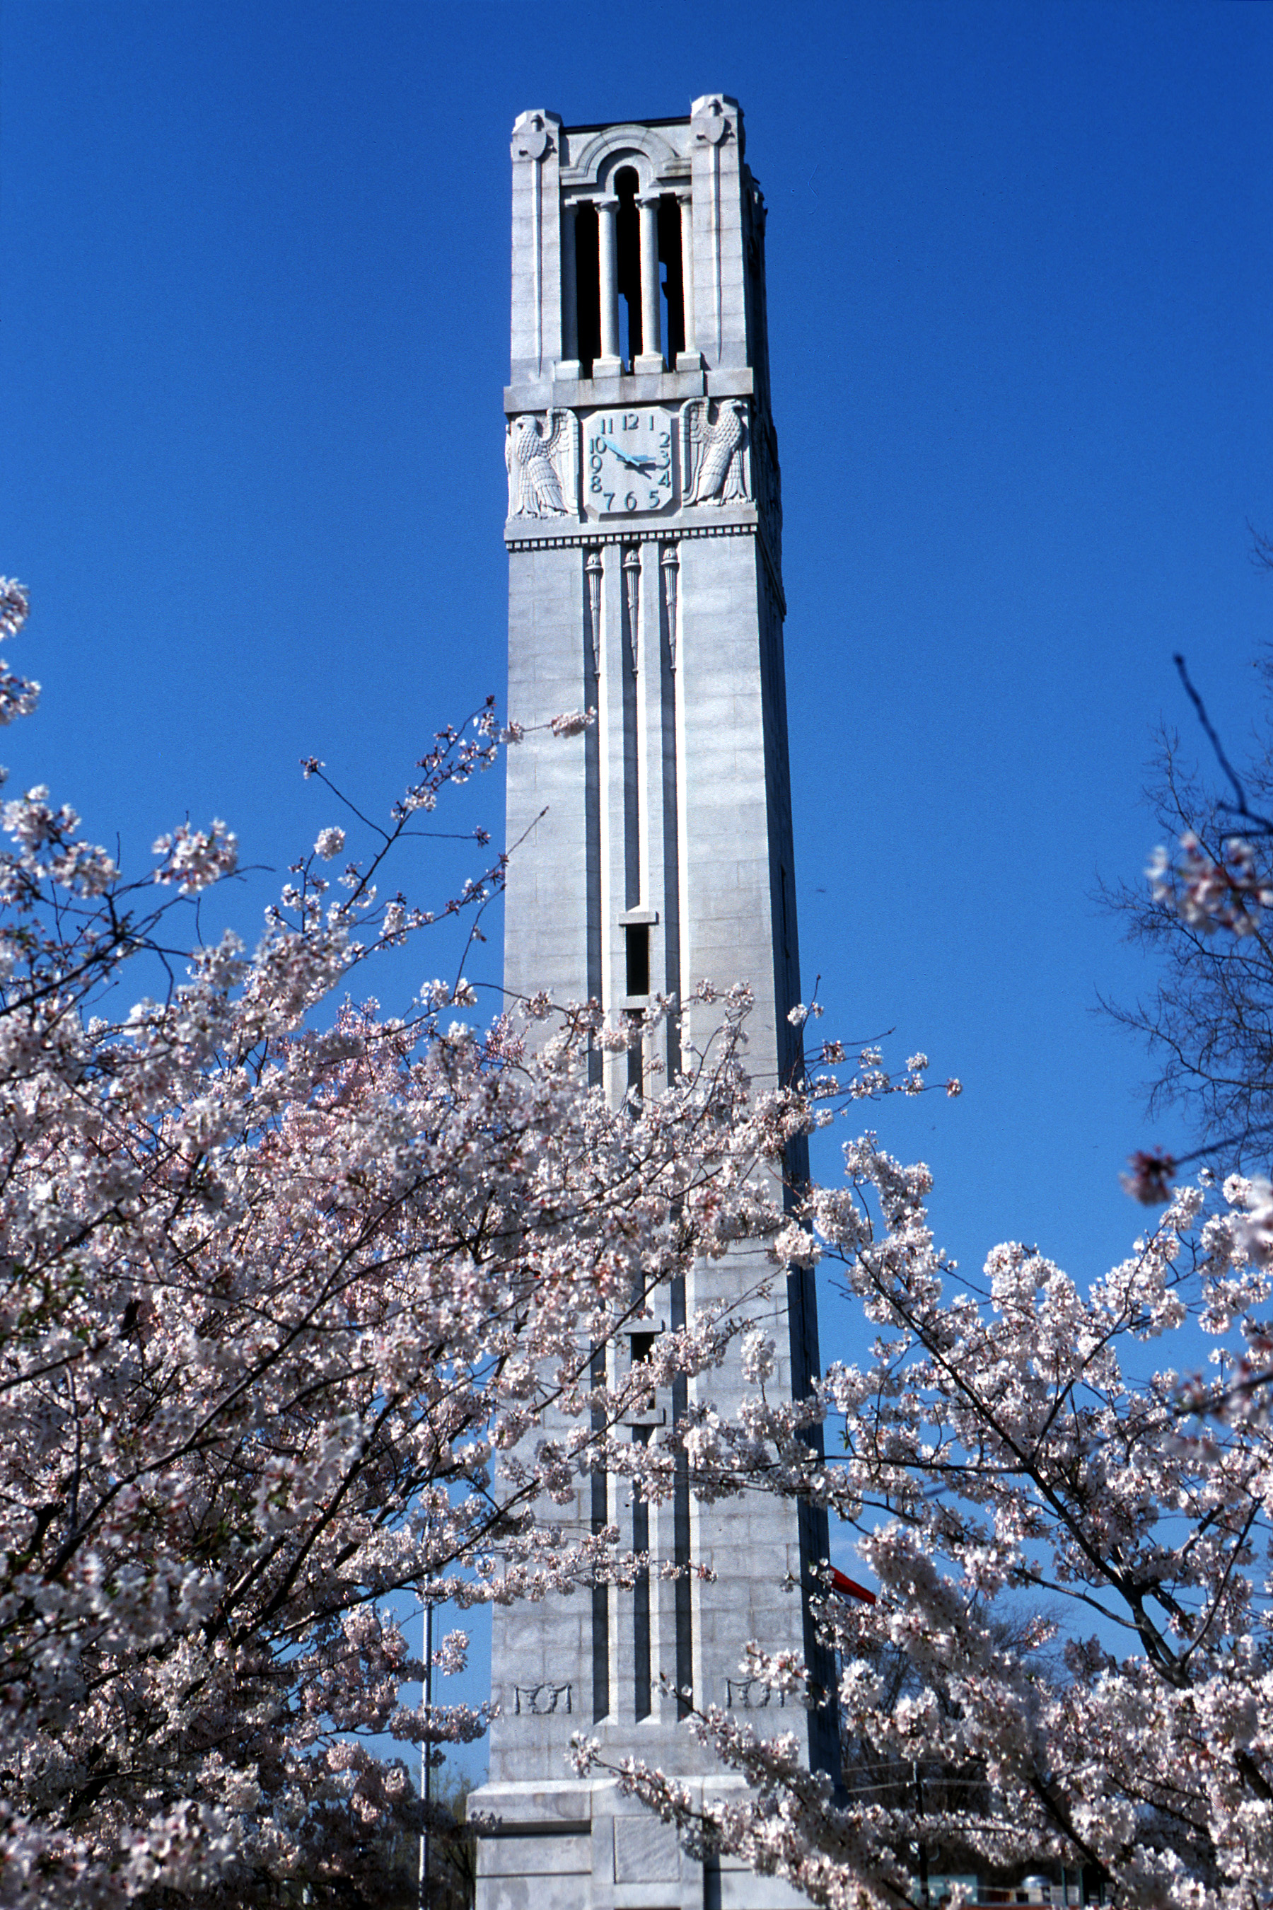

8th SOUTH EASTERN LIE THEORY WORKSHOP

on

ALGEBRAIC AND COMBINATORIAL
REPRESENTATION THEORY

October 9 -11, 2015

North Carolina State University

Principal Speaker: Anne Schilling, UC-Davis

Invited Speakers include:

Daniel Orr, Virginia Tech
Toshiki Nakashima, Sophia University, Japan
Masato Okado, Osaka City University, Japan
Ben Webster, University of Virginia
Jerzy Weyman, University of Connecticut
Peter Tingley, Loyola University, Chicago

Afternoon Discussion Session organized by:

Kyu-Hwan Lee, University of Connecticut

In addition there will be a contributory talk session

Website for the workshop:

http://www4.ncsu.edu/~misra/SELie/index3.htm

Sponsors:

National Science Foundation
North Carolina State University

Contact Information:
Kailash C. Misra, misra@ncsu.edu, (919)515-8784

